

- Yeah nav bar m margin or padding thik krna or logo chota ssa ha
- Jo box ke andar frame bani hui ha vo pure section mei krdo
- Or dono line hai left and right mein vo margin thi kardo
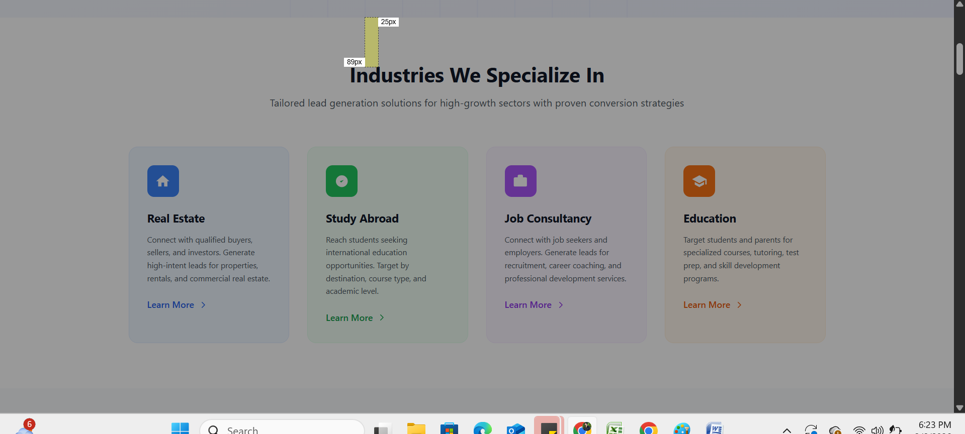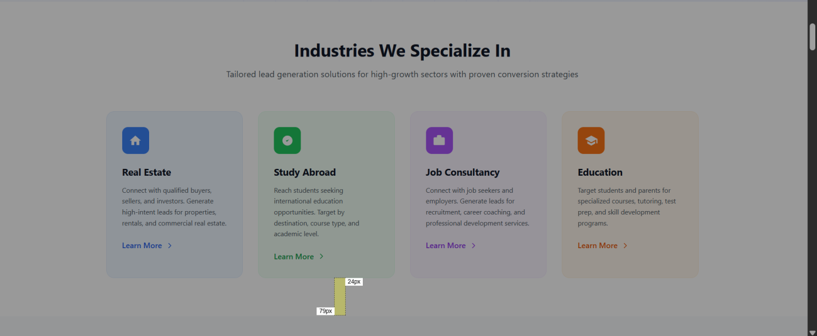

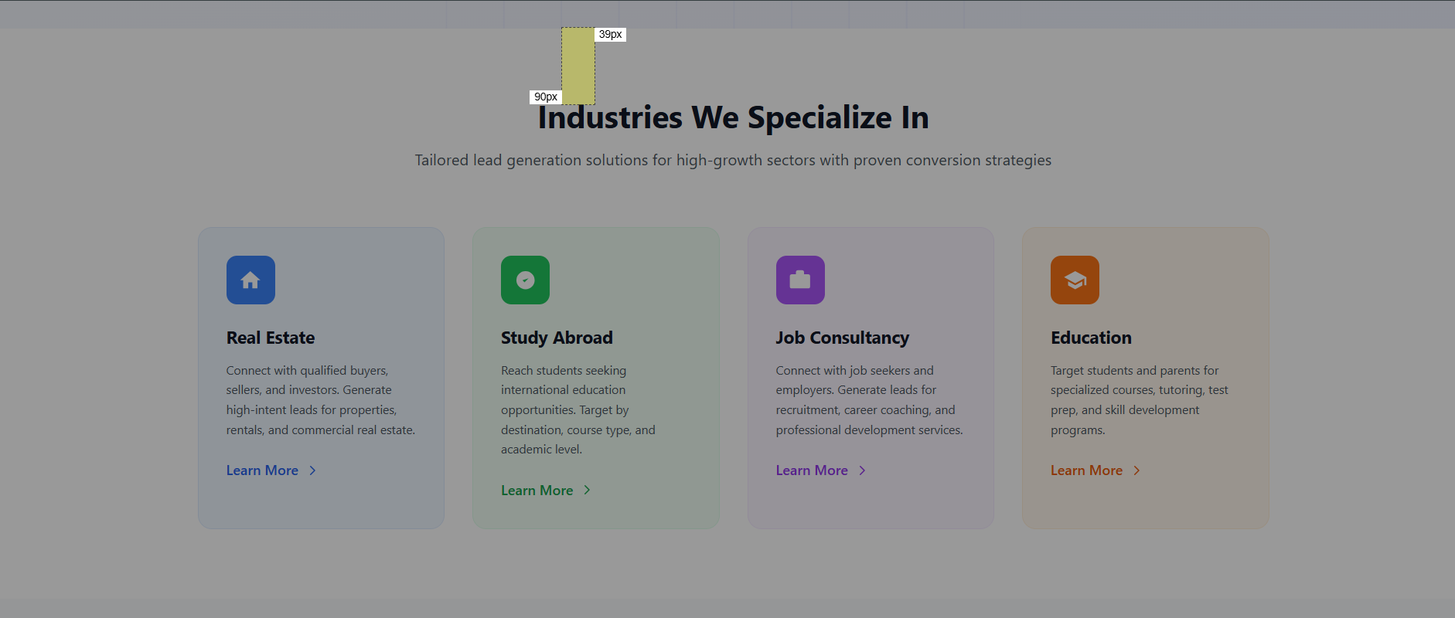
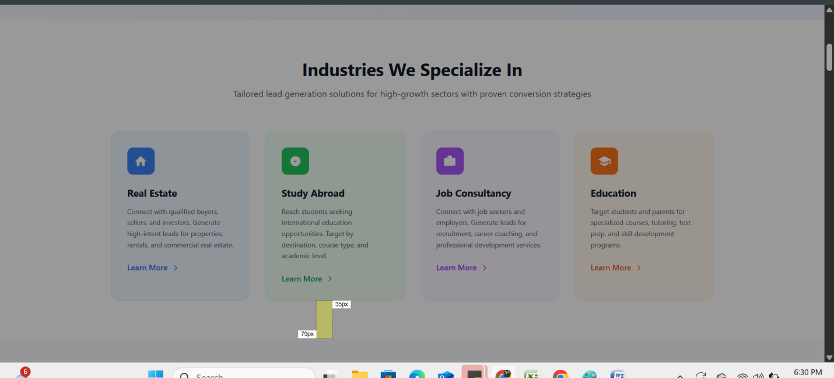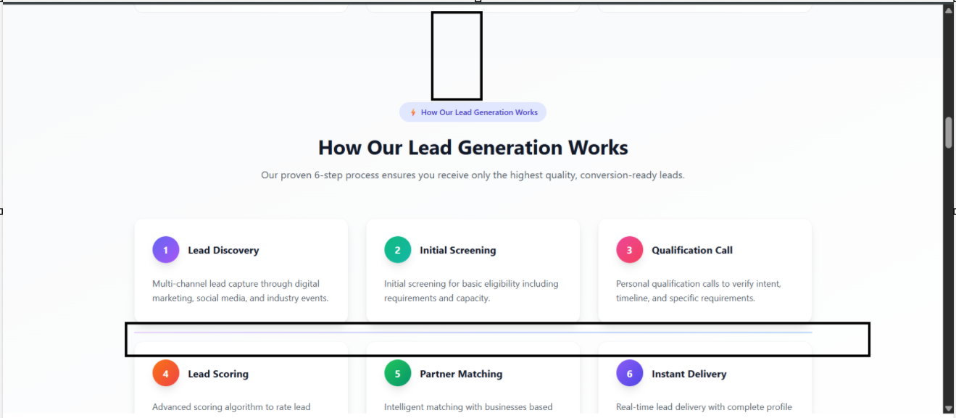
- make the margin proper and remove the extra line proper

 left and right ki margin kam krna ha
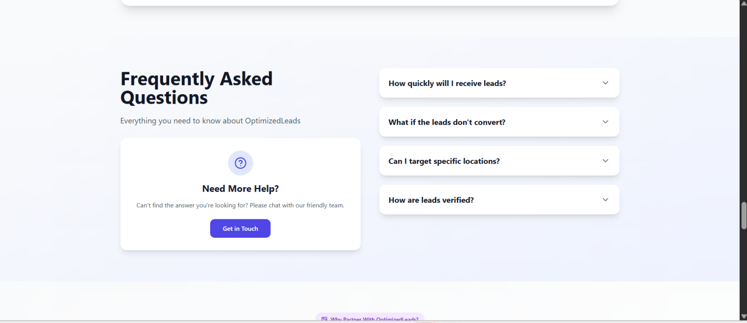
Isme margin or need more wala section or f& Q wala section alag alag krn aha or peopr alighent thik krna = hai

REMOVE STATIC SECTION AND DO NOT USE MONEY BACK GURENTEE AND 100 % Sse relate kuch bhi use nahi krna ha \

